# 

Project Proposal

UMass Lowell

GUI Programming II

Spring 2014

ff

Sereyrath Nov, Bunlong Heng & Andi Milhomme

ff

Table of Contents

Goal Statement 2

Feature Descriptions 2

Basic features 2

User Account Registration 2

Search Engine 3

Favorite Games List 3

Required Components 3

Mockups 4

Targeted Users 8

Potential Issues 8

Tentative Schedule 9

Release 10

Minimum Functionality 10

Nice-to-have features 10

Conceptual features 10

# Goal Statement

GameWorld is a web application which provides instructions on how to get games set up and running on your consoles, handhelds, or PC; along with tips and tricks about the most popular video game consoles in the world.

# Feature Descriptions

## Basic features

GameWorld features the most popular gaming platforms, which includes console such as: PlayStation, Xbox, Sega, NES, and handheld devices such as iPod Touch, Android tablets, and Windows mobile devices. The user will be able to select their platform of interest. Then, they will be able to see its description, facts, and technical specifications. Our application will suggest the best places to purchase the device.

The website will feature a forum where users can discuss and comment about various topics. The forum will also serve as a way to collect feedback on how we can improve and update this website.

In addition, we would like to deliver live updates on the most popular games. We will inform the users about tips and tricks regarding their gaming platform. GameWorld will give detailed instructions on how to set up classic arcades games on the users’ personal computers through emulators.

## User Account Registration

The users will have the option to register and become a member of our community. Certain features will be only available to these registered members.

**Those benefits include:**

* Technical Support
* A “set as favorite” feature
* User profile with flair
* Enhanced discussions
* Notifications about new games and cheat codes release.

## Search Engine

Users will be able to search for game titles, consoles, instructions, cheat codes, etc, by entering keywords in the search bar. The search feature will provide a list of results relevant to the user’s queries.

## Favorite Games List

  Registered users will have the ability to store their favorite consoles or title in a database. Our website will be dynamically served a “top ten “list, tailored to their preferences.Mockups

# Required Components

Aside from HTML, CSS, and JavaScript, we will use various APIs and styling framework most notably:

* jQuery
* jQuery UI
* Twitter Bootstrap
* Forum plugin
* AJAX
* PHP and MySQL.

# Mockups

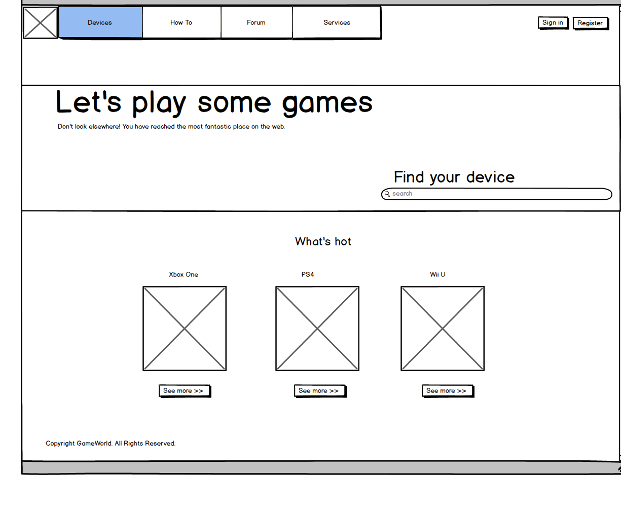

**GameWorld Logo + Other assets**

We collected assets online. We will use them to design graphical components using Adobe Photoshop and maybe Adobe Illustrator if needed. Appropriate text such as device specifications will be added as we go.

**Navigation Menu**

The navbar is divided in 3 sections: The logo, primary links; login and register buttons. We used CSS to style the navbar.

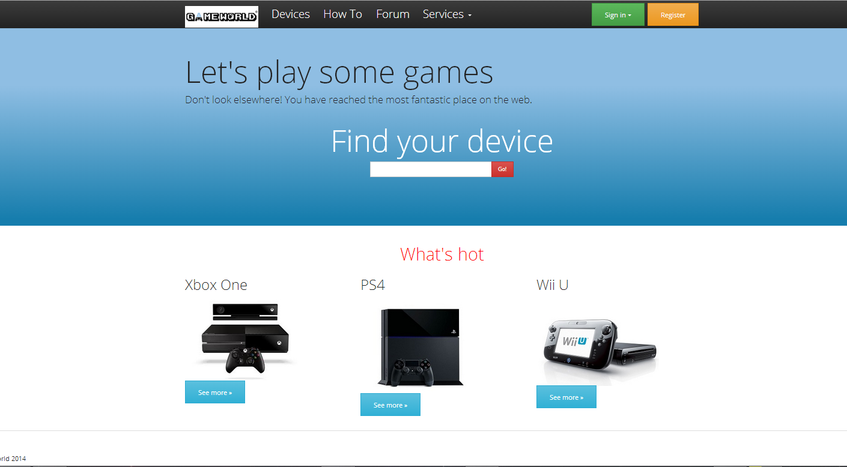

**Bootstrap API**

**Jumbotron**

We will use it as our staring point for a user to find their favorite console.

Our search bar will retrieve desired devices from MySQL databases.

We will also use AJAX to display suggestions while the user is typing.

We will use Bootstrap **Grid System** to layout our entire webpage. These sections will also feature the most popular devices or game titles periodically. Bootstrap has a convenient carousel feature which can be implemented with the help of JavaScript.

In order to save space, we've opted for a dropdown login button. Using the query $('.dropdown-toggle').dropdown();

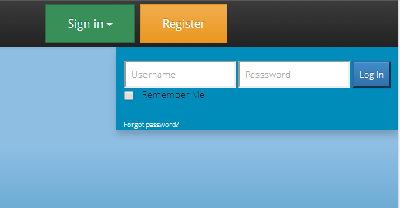

User login information will be stored in the MySQL database. This can be hard to keep secure, so alternative login options might be used such as: Facebook or Steam.

The jQuery validation plugin will notify the user if an invalid input is detected.

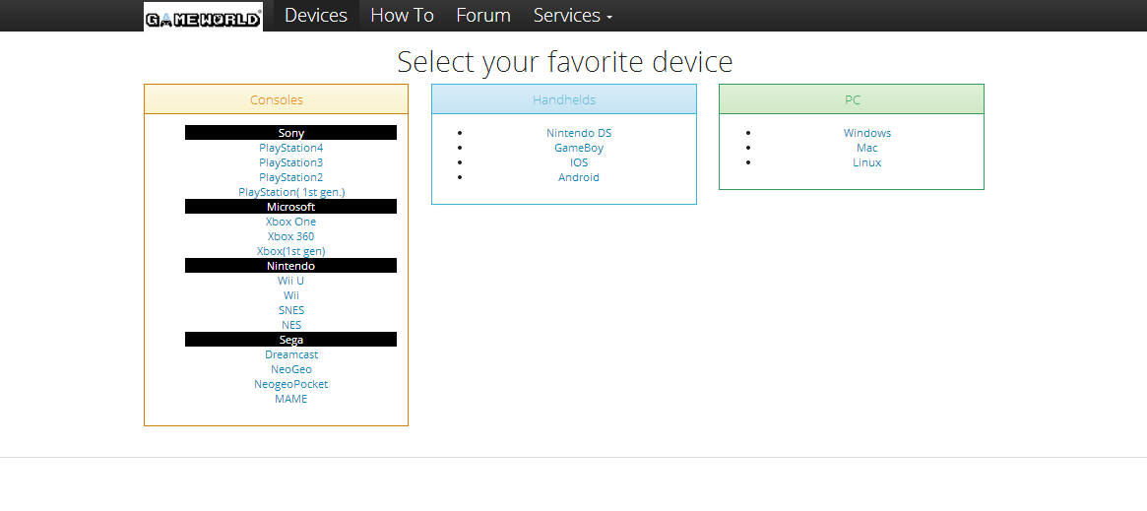

We will sort devices into three categories: Console, Handhelds, and PC so that the user(s) will find their needs quicker.

HTML list tags will sort the elements. When the user selects a device it will bring up a page which will provide all the necessary details. Creating a webpage for every single device might not be practical, that’s why we intend to use JSON to display the contents more efficiently.

Touching up the webpage with our CSS and jQuery UI skills will make the page more vidid and interactive.

# Targeted Users

GameWorld is for the nostalgic, notably those who were born in the late 80’s and early 90’s. GameWorld is also for those who are into the more cutting edge systems. Another targeted group might be those who love video gaming but are not tech-savvy.  For example, some people have bought a new Nintendo Wii, and have no idea how to use that device at its maximum potential, our website will help them achieve that goal.

# Potential Issues

Aside from not having enough time to implement all the desired features, we might also encounter a few other issues. One of the most challenging problems that we might face is not being able to find and retrieve data from other sources. This is probably due to not being able to find the appropriate APIs, or to collect the data ourselves. Updating the trending games live might be extremely challenging.

        Since a major chunk of Internet traffic is shared with mobile devices, we predict that certain features might not show properly on the smaller devices. We intend to make the website responsive, but we don’t know if all the features will work as expected.

# Tentative Schedule

**Name initials**: BH = Bulong Heng; SN = Sereyrath Nov; AM = Andi Milhomme

|  |  |  |  |  |
| --- | --- | --- | --- | --- |
| Task | Details | Person Responsible | Milestone | Completion date |
| Basic Layout | * Homepage * Navigation Bar * Logo * Primary Links * Asset collection | BH + AM + SN | Alpha | 02/04/2014 |
| Elevator Pitch | * Motivation * Goal | BH+AM+SN | Alpha | 02/06/2014 |
| User Registration | * User credentials storage * Favorite list creation | BH + AM | Alpha | 02/18/2014 |
| Data Collection | * Descriptions * Facts * Technical Specifications | BH + SN + AM | Alpha | 03/ 05/2014 |
| Tips and Tricks | * Tutorial * Fun facts | BH + SN | Beta | 03/15/2014 |
| Forum Implementation |  | AM + SN | Beta |  |
| Live Updates | * Top-ten games suggestions | AM + SN | Beta  v2 | 04/01/2014 |
| Bug testing and Final touches |  | SN + BH + AM | Release Candidate. | 04/28/2014 |
| Presentation |  | SN + BH + AM | RTM  version 1.0 | 05/06/2014 |

# 

# Release

## Minimum Functionality

The minimum functionality for GameWorld should be a list of gaming systems, their descriptions, facts, technical specifications, and cheat code features where it’s applicable. We also intend to at least have a working user registration system in place. In addition, we would like to have the search engine functions properly along with the live update of the top ten games.

## Nice-to-have features

* There are some features that are really nice and we would really like to implement them. They include the price tag implementation, forum and personalized technical support.

## Conceptual features

Live updates of the bestselling video game platforms and titles.

Registered users will have the ability to add each other as a friends, and they can message each other directly.